

**RECIPE DATABASE**

**SUBMITTED TO – Dr. Rajni Aron**

**MADE BY**

**PEARLYN RODRIGUES-S037**

**ARINA SINGHAI- S043**

**MBA TECH DATA SCIENCE**

**SEMESTER IV**

**TABLE OF CONTENTS**

|  |  |  |
| --- | --- | --- |
| **Sno.** | **Content** | **Page No** |
| 1. | Project Description | 3-4 |
| 2. | ER Diagram | 5 |
| 3. | Relational Schema | 6 |
| 4. | Description and Assumptions about the database | 7-8 |
| 5. | Database and Queries | 9-20 |
| 7. | Bibliography | 21 |

1. **PROJECT DESCRIPTION**
2. **Background**

Cooking is a universal activity that brings people together. It is a way to share culture, create memories, and nourish oneself and others. However, keeping track of recipes and ingredient lists can be overwhelming, especially for people who enjoy cooking frequently. This is where a recipe database comes in.

A recipe database is a digital resource that stores information about recipes, ingredients, and cooking instructions. It can be used to easily search for and access recipes, organize ingredients and shopping lists, and share recipes with others. A recipe database can save time, reduce waste, and increase the enjoyment of cooking.

1. **Objective**
2. The objective of creating a recipe database is to provide a centralized platform for users to store and access their favourite recipes.
3. To design ER diagram for the database
4. To design relation schema for the database
5. To implement the database
6. **Benefits**

The layout of this recipe database offers several benefits as compared to other recipe database layouts. First, the use of primary and foreign keys ensures that the data is organized and relationships between tables are maintained. This ensures that data can be easily accessed and modified without losing its integrity.

Second, the inclusion of ingredient information in the Recipe_Ingredients table allows for easy scaling and customization of recipes based on dietary needs or preferences. This feature allows users to easily modify recipes to fit their specific needs.

Third, The inclusion of user reviews and ratings of recipes in separate tables provides valuable feedback to other users, allowing them to make more informed decisions about which recipes to try.

Overall, the layout of this recipe database provides a user-friendly, efficient, and secure platform for storing and accessing recipes. Its customization and feedback features make it a valuable resource for users interested in cooking and recipe sharing.

1. **Uses**

This recipe database schema is useful for managing and organizing recipe data for individuals, food bloggers, recipe websites, and food-related businesses. The database can be used to store, search, and retrieve recipes by different criteria such as ingredient, category, rating, and user. This can help individuals and businesses to streamline their recipe management process and provide a better user experience for their audience.

For instance, a food blogger can use this database to manage their recipes and ingredients, categorize their recipes, and allow their audience to rate and review their recipes. They can also use the database to personalize their audience's experience by suggesting recipes based on their search and viewing history.

A recipe website can use this database to store and manage many recipes, ingredients, and user data. They can also use this database to generate recipe recommendations for their users and display popular recipes based on user ratings and reviews.

This recipe database schema can also be beneficial for larger food-related businesses, such as hotels and small restaurants. They can use this database to manage their recipes and ingredients inventory, and plan their menus based on popular and highly rated recipes. This can help them to increase efficiency and reduce food waste by using ingredients across multiple recipes.

Some other potential uses of the schema are:

* Inventory management: Businesses could use this database to manage their ingredient inventory and monitor ingredient usage for each recipe.
* Menu creation: Restaurants, cafes, or catering businesses could use this database to create menus based on the recipes and ingredients stored in the database.
* Collaborative recipe development: Multiple users could contribute and collaborate on recipe development within the database, allowing for a diverse range of recipes and ideas to be shared and refined over time.
* Meal planning: Individuals or businesses could use this database to plan out meals and create shopping lists based on the recipes and ingredients stored in the database.
* Nutritional tracking: By storing nutritional information for each ingredient and recipe, individuals or businesses could use this database to track their daily intake and monitor their nutritional goals. This can be done easily by making minor changes in the schema to store the data

**2.ER DIAGRAM**

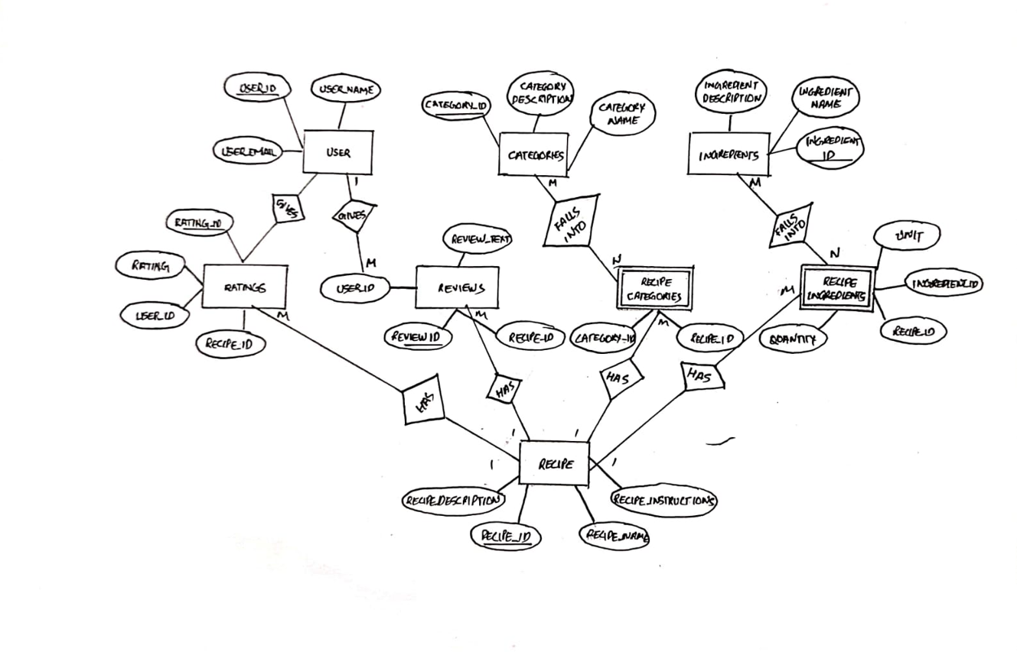

Figure 1. ER diagram of Recipe Database System

**3.RELATIONAL SCHEMA**

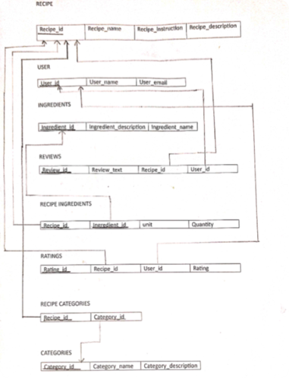

Figure 2. Relational schema of Recipe Database System

**4.DESCRIPTION AND ASSUMPTIONS ABOUT THE DATABASE**

1. **Description**

The Recipes entity has a one-to-many relationship with Recipe_Ingredients and Recipe_Categories, as a recipe can have multiple ingredients and categories. The Ingredients entity has a one-to-many relationship with Recipe_Ingredients, as an ingredient can be used in multiple recipes. The Categories entity also has a one-to-many relationship with Recipe_Categories, as a category can be assigned to multiple recipes.

The Users entity has a one-to-many relationship with both Ratings and Reviews, as a user can rate and review multiple recipes. In terms of the strength of the relationships, Recipes, Ingredients, Categories, and Users entities are all strong entities with their own primary keys. Recipe_Ingredients and Recipe_Categories are weak entities that depend on their respective parent entities to form a primary key.

The primary keys for each table are:

* Recipes: recipe_id
* Ingredients: ingredient_id
* Recipe_Ingredients: (recipe_id, ingredient_id)
* Categories: category_id
* Recipe_Categories: (recipe_id, category_id)
* Ratings: rating_id
* Reviews: review_id
* Users: user_id

The foreign keys in each table are:

* Recipe_Ingredients: recipe_id (references Recipes(recipe_id)), ingredient_id (references Ingredients(ingredient_id))
* Recipe_Categories: recipe_id (references Recipes(recipe_id)), category_id (references Categories(category_id))
* Ratings: recipe_id (references Recipes(recipe_id))
* Reviews: recipe_id (references Recipes(recipe_id))
* Ratings and Reviews: user_id (references Users(user_id))

Normalization of Tables

* Recipes: This table is in not 1NF as it has a primary key but the value of column is not atomic
* Ingredients: This table is in 1NF, 2NF, and 3NF as All non-key attributes (ingredient_name and ingredient_description) depend only on the primary key (ingredient_id).
* Recipe_Ingredients: This table is in 1NF, 2NF,3NF
* Categories: This table is in 1NF, 2NF, and 3NF as it has a primary key and the primary key (recipe_id, category_id) uniquely identifies each record, and there are no transitive dependencies because the table only contains the recipe_id and category_id fields.
* Recipe_Categories: This table is in 1NF, 2NF, and 3NF as it has a composite primary key and all non-key attributes depend on the entire composite primary key.
* Ratings: This table is in 1NF, 2NF, and 3NF as it has a primary key and all non-key attributes depend on the entire primary key.
* Reviews: This table is in 1NF, 2NF but not 3NF as it has a transitive dependency
* Users: This table is in 1NF, 2NF, and 3NF as it has a primary key and all non-key attributes depend on the entire primary key.

1. **Assumptions**

The values inserted in the database are for illustration purposes but not to be relied upon for actual use. However, our database facilitates input of valid and accurate data for one’s specific needs.

**5.IMPLEMENTATION OF THE DATABASE AND QUERIES**

CREATE TABLE Recipes (

recipe_id INT PRIMARY KEY,

recipe_name VARCHAR(255),

recipe_description CLOB,

recipe_instructions CLOB

);

CREATE TABLE Ingredients (

ingredient_id INT PRIMARY KEY,

ingredient_name VARCHAR(255),

ingredient_description CLOB

);

CREATE TABLE Recipe_Ingredients (

recipe_id INT,

ingredient_id INT,

quantity FLOAT,

unit VARCHAR(50),

PRIMARY KEY (recipe_id, ingredient_id),

FOREIGN KEY (recipe_id) REFERENCES Recipes(recipe_id),

FOREIGN KEY (ingredient_id) REFERENCES Ingredients(ingredient_id)

);

CREATE TABLE Categories (

category_id INT PRIMARY KEY,

category_name VARCHAR(255),

category_description CLOB

);

CREATE TABLE Recipe_Categories (

recipe_id INT,

category_id INT,

PRIMARY KEY (recipe_id, category_id),

FOREIGN KEY (recipe_id) REFERENCES Recipes(recipe_id),

FOREIGN KEY (category_id) REFERENCES Categories(category_id)

);

CREATE TABLE Ratings (

rating_id INT PRIMARY KEY,

recipe_id INT,

user_id INT,

rating FLOAT,

FOREIGN KEY (recipe_id) REFERENCES Recipes(recipe_id)

);

CREATE TABLE Reviews (

review_id INT PRIMARY KEY,

recipe_id INT,

user_id INT,

review_text CLOB,

FOREIGN KEY (recipe_id) REFERENCES Recipes(recipe_id)

);

CREATE TABLE Users (

user_id INT PRIMARY KEY,

user_name VARCHAR(255),

user_email VARCHAR(255)

);

INSERT INTO Recipes (recipe_id, recipe_name, recipe_description, recipe_instructions) VALUES(1, 'Spaghetti Carbonara', 'An Italian pasta dish made with eggs, cheese, bacon, and black pepper',

'1. Cook spaghetti according to package instructions.

2. In a separate pan, fry the bacon until crispy.

3. In a bowl, whisk together the eggs, cheese, and black pepper.

4. Drain the spaghetti and add it to the pan with the bacon.

5. Pour the egg mixture over the spaghetti and stir until the eggs are cooked.

6. Serve hot.');

INSERT INTO Recipes (recipe_id, recipe_name, recipe_description, recipe_instructions) VALUES(2, 'Chicken Tikka Masala', 'A popular Indian dish made with marinated chicken cooked in a spiced tomato-based sauce',

'1. Marinate chicken in yogurt and spices for at least an hour.

2. Grill or roast chicken until cooked through.

3. In a separate pan, cook onions and garlic until soft.

4. Add tomatoes, cream, and spices to the pan and simmer for 10 minutes.

5. Add the cooked chicken to the sauce and simmer for another 5 minutes.

6. Serve hot with rice or naan bread.');

INSERT INTO Recipes (recipe_id, recipe_name, recipe_description, recipe_instructions) VALUES(3, 'Beef Stroganoff', 'A Russian dish made with sautéed beef in a sour cream sauce, served over egg noodles',

'1. Cook egg noodles according to package instructions.

2. In a separate pan, sauté beef until browned.

3. Add onions and mushrooms to the pan and cook until softened.

4. Add flour and beef broth to the pan and stir until thickened.

5. Add sour cream and stir until heated through.

6. Serve hot over the cooked egg noodles.');

INSERT INTO Recipes (recipe_id, recipe_name, recipe_description, recipe_instructions)

VALUES (4, 'Grilled Salmon', 'A healthy and flavorful dish made with fresh salmon and grilled to perfection',

'1. Season salmon fillets with salt and pepper.

2. Grill salmon over medium-high heat until cooked through.

3. Serve hot with your favorite side dishes.');

INSERT INTO Recipes (recipe_id, recipe_name, recipe_description, recipe_instructions)

VALUES (5, 'Pesto Pasta', 'A classic Italian dish made with fresh basil pesto and pasta',

'1. Cook pasta according to package instructions.

2. In a separate pan, sauté garlic until fragrant.

3. Add fresh basil pesto to the pan and heat through.

4. Drain the pasta and add it to the pan with the pesto.

5. Toss the pasta until coated with the pesto sauce.

6. Serve hot with grated Parmesan cheese.');

INSERT INTO Recipes (recipe_id, recipe_name, recipe_description, recipe_instructions)

VALUES (6, 'Beef and Broccoli Stir-Fry', 'A popular Chinese dish made with tender beef and crisp broccoli in a savory sauce',

'1. Cut beef into thin strips and marinate in soy sauce and cornstarch.

2. Blanch broccoli in boiling water until crisp-tender.

3. In a wok or large pan, stir-fry beef until browned.

4. Add garlic and ginger to the pan and stir-fry until fragrant.

5. Add broccoli and stir-fry for another minute.

6. Add oyster sauce and a little water to the pan and stir until heated through.

7. Serve hot over steamed rice.');

INSERT INTO Recipes (recipe_id, recipe_name, recipe_description, recipe_instructions)

VALUES (7, 'Vegetable Lasagna', 'A hearty and flavorful vegetarian dish made with layers of pasta, vegetables, and cheese',

'1. Cook lasagna noodles according to package instructions.

2. In a separate pan, sauté vegetables such as bell peppers, zucchini, and mushrooms until softened.

3. In a bowl, mix ricotta cheese with egg, Parmesan cheese, and Italian seasoning.

4. In a baking dish, layer the cooked lasagna noodles, vegetables, and cheese mixture.

5. Repeat layers until all ingredients are used up.

6. Top with shredded mozzarella cheese and bake in the oven until bubbly and golden brown.

7. Serve hot with a side salad.');

INSERT INTO Recipes VALUES(8,'Chicken Alfredo','An Italian-American dish made with fettuccine pasta and a creamy Parmesan sauce','1. Cook fettuccine pasta according to package instructions.

2. In a separate pan, cook chicken until browned and cooked through.

3. Add garlic and cream to the pan and simmer until the sauce thickens.

4. Add Parmesan cheese and stir until melted.

5. Drain the cooked pasta and add it to the pan with the sauce.

6. Toss until the pasta is coated with the sauce.

7. Serve hot with a sprinkle of parsley and extra Parmesan cheese.');

INSERT INTO Recipes (recipe_id, recipe_name, recipe_description, recipe_instructions) VALUES(9,'Beef Tacos','A Mexican dish made with seasoned ground beef, lettuce, tomato, cheese, and taco shells',

'1. Brown ground beef in a pan and drain off any excess fat.

2. Add taco seasoning and a little water to the pan and simmer until the beef is fully seasoned.

3. Warm up taco shells in the oven or microwave.

4. Assemble tacos with lettuce, tomato, cheese, and any other desired toppings.

5. Serve hot with salsa and guacamole.');

INSERT INTO Recipes (recipe_id, recipe_name, recipe_description, recipe_instructions)

VALUES(10,'Sushi Rolls', 'A Japanese dish made with rice, seaweed, and various fillings such as fish, vegetables, and avocado','1. Cook sushi rice according to package instructions.

2. Lay a sheet of seaweed on a bamboo mat and spread rice over the seaweed.

3. Add desired fillings such as salmon, tuna, cucumber, and avocado.

4. Roll the sushi tightly using the bamboo mat.

5. Slice the sushi into bite-sized pieces.

6. Serve cold with soy sauce, pickled ginger, and wasabi.');

INSERT INTO Ingredients (ingredient_id, ingredient_name, ingredient_description) VALUES(1, 'Spaghetti', 'A type of pasta made from wheat flour and water');

INSERT INTO Ingredients (ingredient_id, ingredient_name, ingredient_description) VALUES(2, 'Eggs', 'A staple food in many cultures and a common ingredient in many dishes');

INSERT INTO Ingredients (ingredient_id, ingredient_name, ingredient_description) VALUES(3, 'Parmesan Cheese', 'A hard, Italian cheese that is commonly used in pasta dishes');

INSERT INTO Ingredients (ingredient_id, ingredient_name, ingredient_description) VALUES(4, 'Bacon', 'A type of salt-cured pork that is typically sliced thin and fried');

INSERT INTO Ingredients (ingredient_id, ingredient_name, ingredient_description) VALUES(5, 'Chicken', 'A common type of poultry that is often used in a variety of dishes');

INSERT INTO Ingredients (ingredient_id, ingredient_name, ingredient_description) VALUES(6, 'Broccoli', 'A green vegetable that is high in vitamins and fiber');

INSERT INTO Ingredients (ingredient_id, ingredient_name, ingredient_description) VALUES(7, 'Lasagna Noodles', 'Flat, wide pasta noodles that are commonly used in lasagna dishes');

INSERT INTO Ingredients (ingredient_id, ingredient_name, ingredient_description) VALUES(8, 'Ricotta Cheese', 'A soft, Italian cheese that is commonly used in pasta dishes');

INSERT INTO Ingredients (ingredient_id, ingredient_name, ingredient_description) VALUES(9, 'Bell Peppers', 'A type of vegetable that comes in various colors and is often used in a variety of dishes');

INSERT INTO Ingredients (ingredient_id, ingredient_name, ingredient_description) VALUES(10, 'Mushrooms', 'A type of fungus that is commonly used in a variety of dishes');

INSERT INTO Ingredients (ingredient_id, ingredient_name, ingredient_description) VALUES(11 ,'Beef', 'A common type of meat that is often used in a variety of dishes');

INSERT INTO Ingredients (ingredient_id, ingredient_name, ingredient_description) VALUES(12,'Salmon', 'Meat of the salmon fish ');

INSERT INTO Recipe_Ingredients (recipe_id, ingredient_id, quantity, unit) VALUES (1, 1, 1, 'box');

INSERT INTO Recipe_Ingredients (recipe_id, ingredient_id, quantity, unit) VALUES(1, 2, 1, 'jar');

INSERT INTO Recipe_Ingredients (recipe_id, ingredient_id, quantity, unit) VALUES(1, 3, 2, 'cups');

INSERT INTO Recipe_Ingredients (recipe_id, ingredient_id, quantity, unit) VALUES (1, 4, 2, 'cups');

INSERT INTO Recipe_Ingredients (recipe_id, ingredient_id, quantity, unit) VALUES (1, 5, 1, 'pound');

INSERT INTO Recipe_Ingredients (recipe_id, ingredient_id, quantity, unit) VALUES (1, 6, 1, 'head');

INSERT INTO Recipe_Ingredients (recipe_id, ingredient_id, quantity, unit) VALUES (1, 7, 9, 'sheets');

INSERT INTO Recipe_Ingredients (recipe_id, ingredient_id, quantity, unit) VALUES (1, 8, 1, 'cup');

INSERT INTO Recipe_Ingredients (recipe_id, ingredient_id, quantity, unit) VALUES (1, 9, 1, 'each');

INSERT INTO Recipe_Ingredients (recipe_id, ingredient_id, quantity, unit) VALUES (2, 2, 1, 'can');

INSERT INTO Recipe_Ingredients (recipe_id, ingredient_id, quantity, unit) VALUES (2, 3, 1, 'cup');

INSERT INTO Recipe_Ingredients (recipe_id, ingredient_id, quantity, unit) VALUES (2, 4, 1, 'cup');

INSERT INTO Recipe_Ingredients (recipe_id, ingredient_id, quantity, unit) VALUES (2, 5, 1, 'pound');

INSERT INTO Recipe_Ingredients (recipe_id, ingredient_id, quantity, unit) VALUES (2, 6, 1, 'bunch');

INSERT INTO Recipe_Ingredients (recipe_id, ingredient_id, quantity, unit) VALUES (2, 10, 8, 'ounces');

INSERT INTO Recipe_Ingredients (recipe_id, ingredient_id, quantity, unit) VALUES (3, 2, 1, 'can');

INSERT INTO Recipe_Ingredients (recipe_id, ingredient_id, quantity, unit) VALUES (3, 3, 1, 'cup');

INSERT INTO Recipe_Ingredients (recipe_id, ingredient_id, quantity, unit) VALUES (3, 4, 1, 'cup');

INSERT INTO Recipe_Ingredients (recipe_id, ingredient_id, quantity, unit) VALUES (3, 5, 1, 'pound');

INSERT INTO Recipe_Ingredients (recipe_id, ingredient_id, quantity, unit) VALUES (3, 6, 1, 'bunch');

INSERT INTO Recipe_Ingredients (recipe_id, ingredient_id, quantity, unit) VALUES (3, 10, 8, 'ounces');

INSERT INTO Recipe_Ingredients (recipe_id, ingredient_id, quantity, unit) VALUES (4, 12, 1, 'filleted fish');

INSERT INTO Recipe_Ingredients (recipe_id, ingredient_id, quantity, unit) VALUES (4, 2, 1, '');

INSERT INTO Recipe_Ingredients (recipe_id, ingredient_id, quantity, unit) VALUES (5, 2, 1, 'can');

INSERT INTO Recipe_Ingredients (recipe_id, ingredient_id, quantity, unit) VALUES (5, 3, 1, 'cup');

INSERT INTO Recipe_Ingredients (recipe_id, ingredient_id, quantity, unit) VALUES (5, 4, 1, 'cup');

INSERT INTO Recipe_Ingredients (recipe_id, ingredient_id, quantity, unit) VALUES (5, 5, 1, 'pound');

INSERT INTO Recipe_Ingredients (recipe_id, ingredient_id, quantity, unit) VALUES (5, 6, 1, 'bunch');

INSERT INTO Recipe_Ingredients (recipe_id, ingredient_id, quantity, unit) VALUES (5, 9, 1, 'each');

INSERT INTO Recipe_Ingredients (recipe_id, ingredient_id, quantity, unit) VALUES (5, 10, 8, 'ounces');

INSERT INTO Recipe_Ingredients (recipe_id, ingredient_id, quantity, unit) VALUES (6, 11, 1, 'lb');

INSERT INTO Recipe_Ingredients (recipe_id, ingredient_id, quantity, unit) VALUES (6, 6, 2, 'cups');

INSERT INTO Recipe_Ingredients (recipe_id, ingredient_id, quantity, unit) VALUES (6, 9, 1, '');

INSERT INTO Recipe_Ingredients (recipe_id, ingredient_id, quantity, unit) VALUES (6, 1, 8, 'oz');

INSERT INTO Recipe_Ingredients(recipe_id, ingredient_id, quantity, unit) VALUES(7, 7, 12,'');

INSERT INTO Recipe_Ingredients(recipe_id, ingredient_id, quantity, unit) VALUES(7,8,2,'cups');

INSERT INTO Recipe_Ingredients(recipe_id, ingredient_id, quantity, unit) VALUES(7,9,1,'');

INSERT INTO Recipe_Ingredients(recipe_id, ingredient_id, quantity, unit) VALUES(7,10,1,'cup');

INSERT INTO Recipe_Ingredients (recipe_id, ingredient_id, quantity, unit) VALUES (8, 5, 1, 'lb');

INSERT INTO Recipe_Ingredients (recipe_id, ingredient_id, quantity, unit) VALUES (8, 8, 2, 'cups');

INSERT INTO Recipe_Ingredients (recipe_id, ingredient_id, quantity, unit) VALUES (8, 1, 8, 'oz');

INSERT INTO Recipe_Ingredients (recipe_id, ingredient_id, quantity, unit) VALUES (8, 2, 2, '');

INSERT INTO Recipe_Ingredients (recipe_id, ingredient_id, quantity, unit) VALUES (9, 11, 1, 'lb');

INSERT INTO Recipe_Ingredients (recipe_id, ingredient_id, quantity, unit) VALUES(9, 9, 1, '');

INSERT INTO Recipe_Ingredients (recipe_id, ingredient_id, quantity, unit) VALUES (9, 5, 1, 'lb');

INSERT INTO Recipe_Ingredients (recipe_id, ingredient_id, quantity, unit) VALUES (10, 12, 1, '');

INSERT INTO Categories (category_id, category_name, category_description) VALUES (1, 'Italian', 'Recipes that are commonly found in Italian cuisine');

INSERT INTO Categories (category_id, category_name, category_description) VALUES (2, 'Mexican', 'Recipes that are commonly found in Mexican cuisine');

INSERT INTO Categories (category_id, category_name, category_description) VALUES (3, 'Asian', 'Recipes that are commonly found in Asian cuisine');

INSERT INTO Categories (category_id, category_name, category_description) VALUES (4, 'Comfort Food', 'Recipes that are commonly associated with providing a sense of comfort and well-being');

INSERT INTO Recipe_Categories (recipe_id, category_id) VALUES(1, 1);

INSERT INTO Recipe_Categories (recipe_id, category_id) VALUES(2, 3);

INSERT INTO Recipe_Categories (recipe_id, category_id) VALUES(3, 3);

INSERT INTO Recipe_Categories (recipe_id, category_id) VALUES (4, 4);

INSERT INTO Recipe_Categories (recipe_id, category_id) VALUES (5, 1);

INSERT INTO Recipe_Categories (recipe_id, category_id) VALUES(6, 3);

INSERT INTO Recipe_Categories (recipe_id, category_id) VALUES(7, 4);

INSERT INTO Recipe_Categories (recipe_id, category_id) VALUES(8, 1);

INSERT INTO Recipe_Categories (recipe_id, category_id) VALUES (9, 2);

INSERT INTO Recipe_Categories (recipe_id, category_id) VALUES (10, 3);

INSERT INTO Ratings (rating_id, recipe_id, user_id, rating) VALUES(1, 1, 1, 4.5);

INSERT INTO Ratings (rating_id, recipe_id, user_id, rating) VALUES(2, 1, 2, 5);

INSERT INTO Ratings (rating_id, recipe_id, user_id, rating) VALUES(3, 2, 3, 3.5);

INSERT INTO Ratings (rating_id, recipe_id, user_id, rating) VALUES(4, 2, 4, 4);

INSERT INTO Ratings (rating_id, recipe_id, user_id, rating) VALUES(5, 3, 1, 4);

INSERT INTO Ratings (rating_id, recipe_id, user_id, rating) VALUES(6, 3, 2, 4.5);

INSERT INTO Ratings (rating_id, recipe_id, user_id, rating) VALUES (7, 4, 3, 5);

INSERT INTO Ratings (rating_id, recipe_id, user_id, rating) VALUES(8, 4, 4, 4.5);

INSERT INTO Ratings (rating_id, recipe_id, user_id, rating) VALUES(9, 5, 1, 3);

INSERT INTO Ratings (rating_id, recipe_id, user_id, rating) VALUES (10, 5, 2, 3.5);

INSERT INTO Reviews (review_id, recipe_id, user_id, review_text) VALUES (1, 1, 1, 'This recipe was amazing! I loved how easy it was to make and the flavors were fantastic.');

INSERT INTO Reviews (review_id, recipe_id, user_id, review_text) VALUES(2, 1, 2, 'I made this for my family and they all loved it. The only thing I would change is to add a little more garlic.');

INSERT INTO Reviews (review_id, recipe_id, user_id, review_text) VALUES(3, 2, 3, 'This was a decent recipe, but I felt like it was missing something. Maybe some more spices?');

INSERT INTO Reviews (review_id, recipe_id, user_id, review_text) VALUES(4, 2, 4, 'I thought this recipe was really good. I added some extra cheese on top and it turned out great.');

INSERT INTO Reviews (review_id, recipe_id, user_id, review_text) VALUES(5, 3, 1, 'I loved this recipe! The sauce was so flavorful and the shrimp were cooked perfectly.');

INSERT INTO Reviews (review_id, recipe_id, user_id, review_text) VALUES(6, 3, 2, 'This recipe was good, but I think next time I will use less soy sauce. It was a little too salty for me.');

INSERT INTO Reviews (review_id, recipe_id, user_id, review_text) VALUES(7, 4, 3, 'This recipe was delicious! The meat was so tender and the sauce was amazing.');

INSERT INTO Reviews (review_id, recipe_id, user_id, review_text) VALUES(8, 4, 4, 'I made this for dinner last night and it was a hit! My whole family loved it.');

INSERT INTO Reviews (review_id, recipe_id, user_id, review_text) VALUES(9, 5, 1, 'This recipe was just okay for me. I think I prefer more traditional taco recipes.');

INSERT INTO Reviews (review_id, recipe_id, user_id, review_text) VALUES(10, 5, 2, 'I thought this recipe was really good. The avocado salsa was a nice touch.');

INSERT INTO Users (user_id, user_name, user_email) VALUES(1, 'Spock Tellis', 'spock.tell@gmail.com');

INSERT INTO Users (user_id, user_name, user_email) VALUES (2, 'Jerry Dogde', 'jeryyy.dogdee@gmail.com');

INSERT INTO Users (user_id, user_name, user_email) VALUES (3, 'Ollie Brown', 'olliee.brown@gmail.com');

INSERT INTO Users (user_id, user_name, user_email) VALUES (4, 'Millie Singh', 'mill.lee@egmail.com');

/*QUERIES*/

/*1. List the name of recipes with average rating above 4.*/

SELECT DISTINCT R.recipe_id,recipe_name FROM Recipes R, Ratings S WHERE rating>=4 AND R.recipe_id=S.recipe_id;

/*2. Name the category and dish with no chicken*/

SELECT r.recipe_name, c.category_name

FROM Recipes r, Categories c, Recipe_Categories rc

WHERE r.recipe_id = rc.recipe_id

AND rc.category_id = c.category_id

AND r.recipe_id NOT IN ((SELECT recipe_id

FROM Recipe_Ingredients

WHERE ingredient_id IN (SELECT ingredient_id

FROM Ingredients

WHERE ingredient_name = 'Chicken')));

/*3. Name the recipe which falls into Comfort Food and does not contain Brocolli*/

SELECT recipe_name FROM Recipes WHERE recipe_id IN (SELECT recipe_id

FROM Recipe_Categories

WHERE category_id =(SELECT category_id

FROM Categories

WHERE category_name = 'Comfort Food')) AND recipe_id NOT IN (SELECT recipe_id

FROM Recipe_Ingredients

WHERE ingredient_id = (SELECT ingredient_id

FROM Ingredients

WHERE ingredient_name = 'Broccoli'));

/*4. Retrieve all recipes which fall into asian catgory*/

SELECT r.recipe_name

FROM recipes r

JOIN recipe_categories rc ON r.recipe_id = rc.recipe_id

JOIN categories c ON rc.category_id = c.category_id

WHERE c.category_name = 'Asian';

/*5. Average Rating of the recipe with recipe_name='Chicken Tikka Masala' */

SELECT AVG(r.rating) FROM ratings r ,recipes re WHERE re.recipe_name ='Chicken Tikka Masala' and r.recipe_id=re.recipe_id;

/*6. List all reviews made by user 1*/

select U.user_name,review_text from users U, reviews R where U.user_id=R.user_id and U.user_id=1;

/*7. which recipe got the highest rating?*/

select rating,recipe_name from ratings r, recipes rr where r.recipe_id=rr.recipe_id and rating=5;

/*8.Retrieve the category of a recipe on the basis of recipe_id */

SELECT c.category_name

FROM categories c

JOIN recipe_categories rc ON c.category_id = rc.category_id

WHERE rc.recipe_id ='4';

/*9.Query to get all recipes and their average ratings*/

SELECT r.recipe_name, AVG(ra.rating) AS average_rating

FROM recipes r

LEFT JOIN ratings ra ON r.recipe_id = ra.recipe_id

GROUP BY r.recipe_name;

/*10.retrieve steps on how to make Pesto Pasta*/

select recipe_instructions from recipes where recipe_name='Pesto Pasta';

/*11.Query to get recipe which involves baking */

select recipe_name from recipes where recipe_instructions LIKE '%baking%';

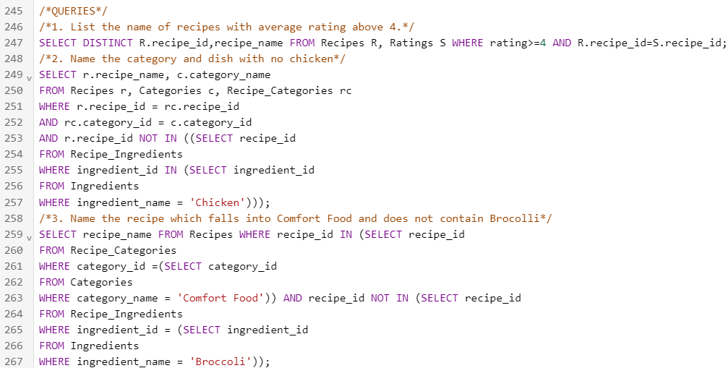

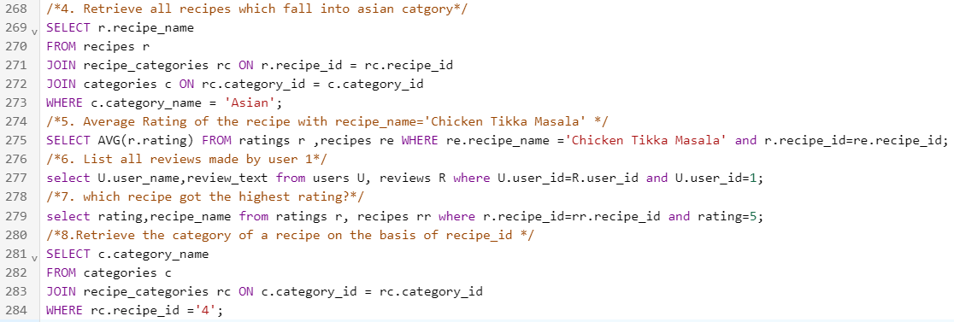

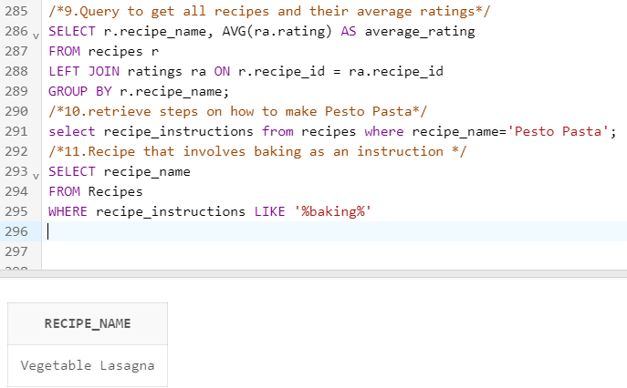

**6.BIBLIOGRAPHY**

1. Silberschatz, A., Korth, H. F., & Sudarshan, S. (2010). Database System Concepts. McGraw-Hill Education
2. Kimball, R., Ross, M., Thornthwaite, W., Mundy, J., & Becker, B. (2013). The Data Warehouse Toolkit: The Definitive Guide to Dimensional Modeling. Wiley.
3. <https://www.tarladalal.com/vegetable-lasagne--indian-style-veg-lasagna-31090r>
4. <https://www.allrecipes.com/recipe/11786/hearty-vegetable-lasagna/>